Code Smell 1: Dead Code

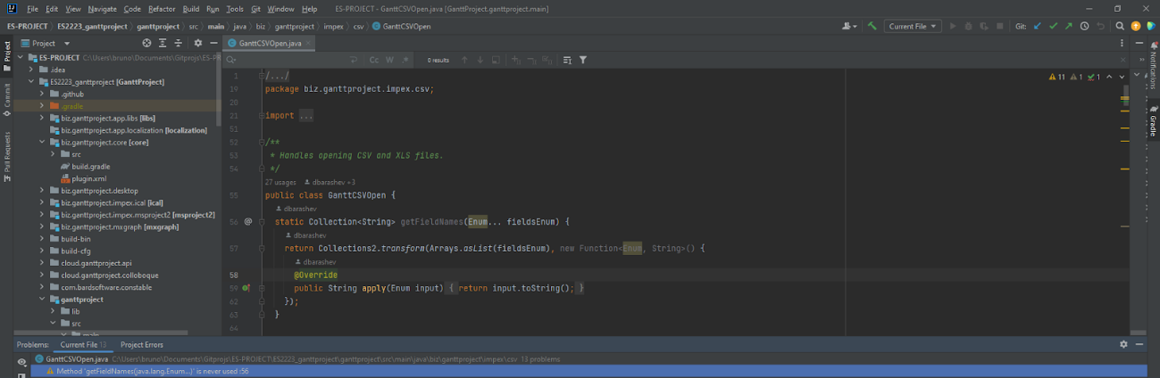

**Location of the code smell from repository root:**

ganttproject/src/main/java/biz/ganttproject/impex/csv/GanttCSVOpen.java, line 56.

**Explanation:**

The method getFieldNames(Enum... fieldsEnum) is never used, also known as dead code.

**Refactoring proposal:**

This method should be deleted.